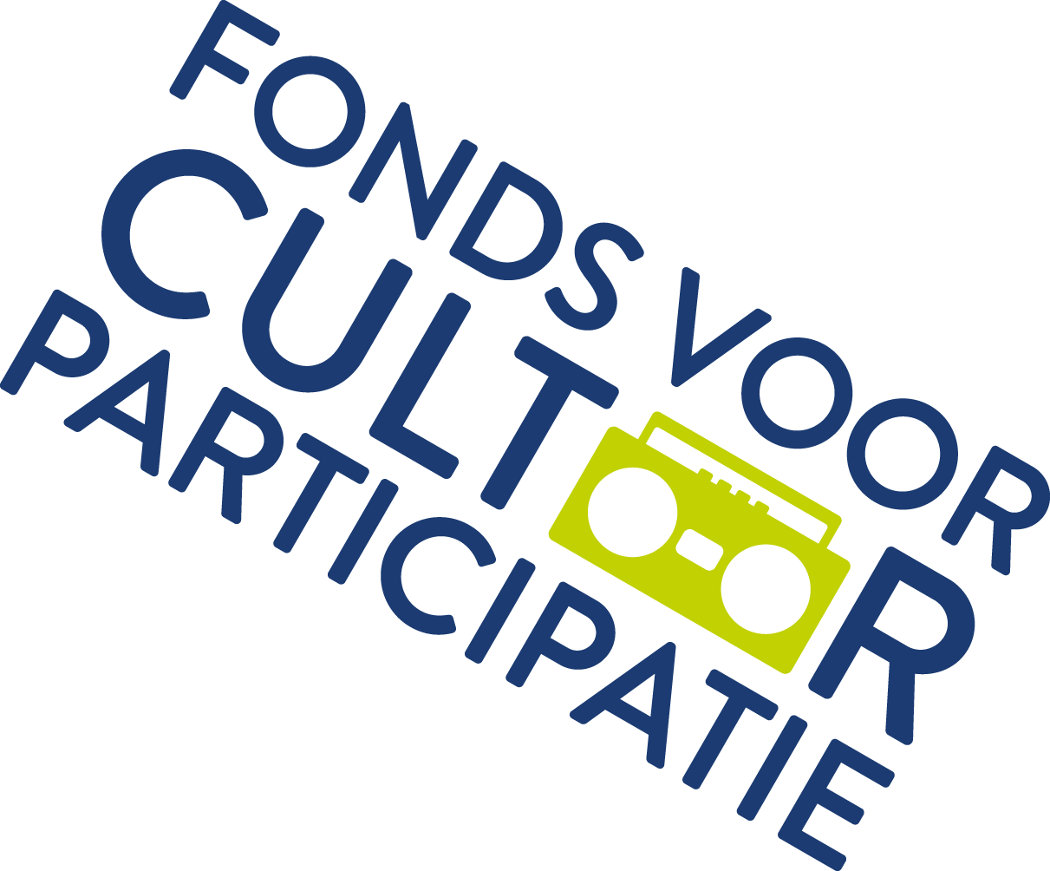

Project plan guidelines
Cultural Education with Quality
2021-2024 Caribbean Netherlands

A mandatory part of an application for Cultural Education with Quality 2021-2024 Caribbean Netherlands is the project plan. A project plan is a structured set-up of the goals, how you achieve these goals and what is needed for that. The lead party writes the project plan in consultation with the cooperation partners. This means that all parties know what the objectives are and what role they play. The project plan may contain a maximum of 7,500 words and is written according to the table of contents formulated here.

The project plan is read by the Fund in conjunction with the application form. In the application form you provide a brief answer to the questions asked by the Fund. You also enter the key figures of your intended performance and budget here. In the project plan you have more space for substantive explanation and a specified budget.
What can be applied for?
An application for a multi-year subsidy is submitted to realize and sustainably strengthen the quality of cultural education. This is carried out through intensive collaboration between education and the cultural sector. The collaboration is based on an educational vision of cultural education and should focus on the cultural development of the child. Attention is also paid to increasing the equal opportunities for children. The way in which the goal is achieved is through:
a. the development and implementation of cultural educational activities and materials aimed at sustainably enhancing the quality of cultural education at the school. These activities and materials are developed together by education and the cultural environment. In doing so, a link will be sought with relevant curriculum innovations; and
b. increasing the professionalization of teachers, cultural partners and lead actors with regard to cultural education.
The primary target group for this scheme is primary education and the cultural field. Secondary education can, however, be a cooperation partner.

Table of contents project plan
The parts below must be included in the project plan. Preferably you also keep to this table of contents. The project plan may contain a maximum of 7,500 words.

1. Summary

2 Introduction
- the internal and external context in which the project is located
- the reason or problem statement to start Cultural Education with Quality

3. Reflection on the state of affairs Cultural Education with Quality
- an analysis of the position of cultural education within the regional or local context (support for education, cultural institutions and politics)
- reflection on previous impulses to strengthen cultural education, such as the music impulse or other initiatives.

4. Activities 2021-2022
- the project objectives translated into the local situation
- the demarcation of the project and its relationship with other cultural education activities
- the results at the end of the project
- description of the activities in relation to the project objectives and the relationship between the activities
- How is the Equality theme given shape in the project?

5. Collaboration of secretary, education, cultural institutions and others
- partnership and division of tasks and roles
- involvement of parties in planning

6. Knowledge sharing
- explanation of knowledge-sharing activities for schools and cultural institutions
- the way in which schools and cultural institutions are involved in the sharing of knowledge
- use of existing networks of schools and cultural institutions
- topics on which knowledge is shared

7. Monitoring and evaluation
- explanation of monitoring activities and objectives
- questions that guide the monitoring and evaluation
- how schools, cultural institutions and other relevant parties (stakeholders) are involved in the monitoring and evaluation

8. Planning

9. Budget
- budget in your own format
- explanation of the budget

